SCHEDULES: (ADDED TO DASHBOARD)

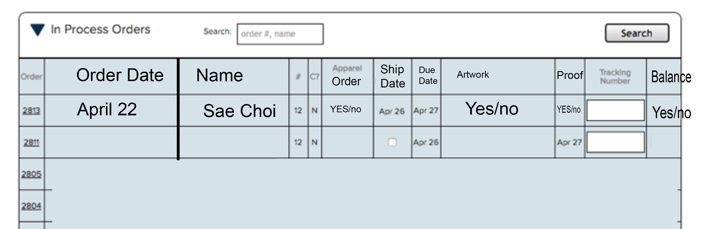

1. Purchase Order # generated when information of the customer detail of order is finalized.
2. Name of Customer
3. Quantity of shirts
4. Custom Names/numbers --- (it will say Yes or NO if excel sheet is added)
5. Apparels ordered (assigned by distributors)- (It will say YES if the garments were ordered. NO if the garments were not ordered.) How you determine if the garments are ordered is when you click on the YES or NO it will go to a separate page. Within the page it will have rows or when you click on ORDER PAGE you can change it within there.

* How to set distributors, cost, receive date… ( like garment picture)
* Do we need a page to manage Distributors ( add, edit, remove …)

1. DUE DATE

* How to get due date

1. SHIP DATE (when it needs to ship to get to clients)
2. Tracking Number
3. Artwork is attached (yes or no if it files are attached)
4. Proof approved (admin must change manually)
5. Balance (yes or no if customer paid full on website, or left deposit)

When Its Due Date is that day Red Exclamation point is highlighted

When it is competed changes it to Green (when TRACKING # is created or clicked completed)

* When and how tracking number created?
* Should we need complete button to change order status?

ORDER #

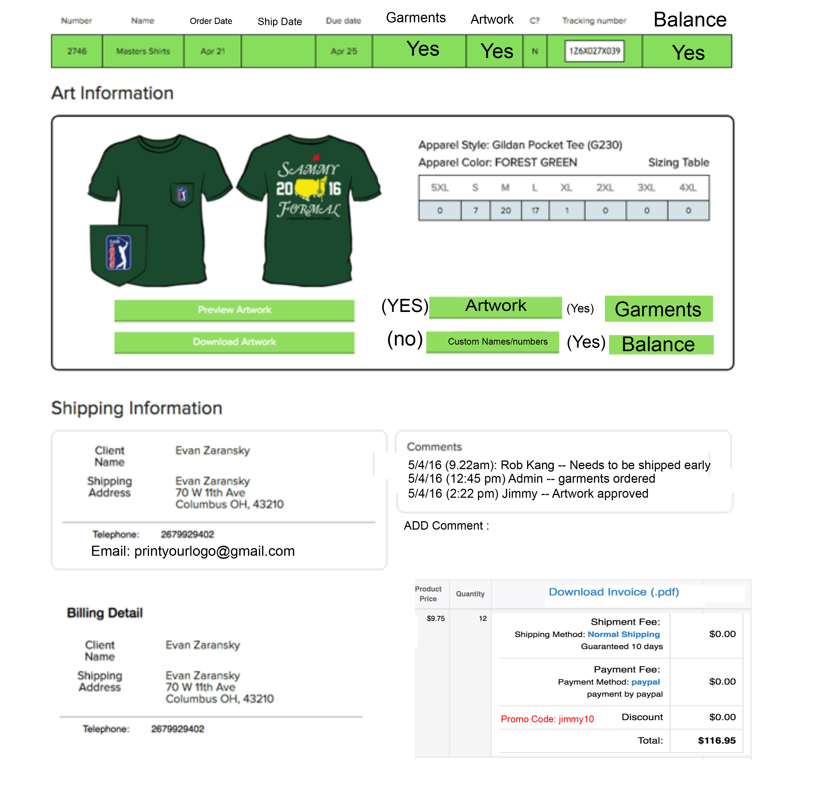

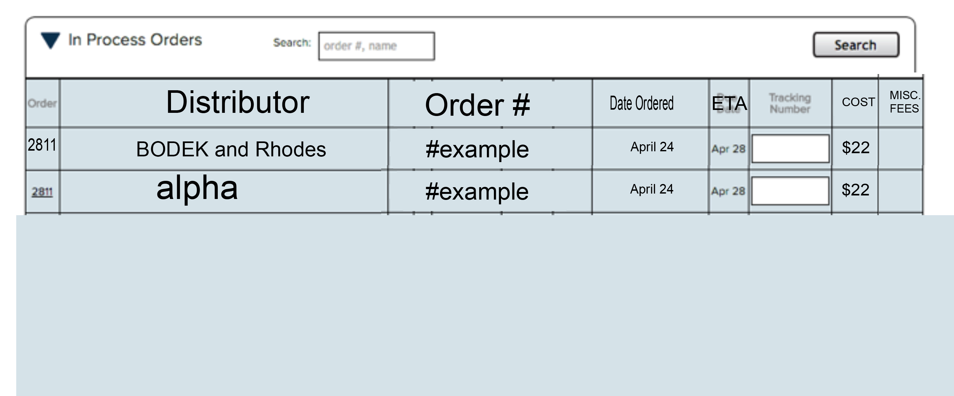

(------ garment page-------)

When you click the Purchase order # Tab

All of customers information is listed.

1) Quantity of shirts:

2) Type of shirt

3) Color of shirts

4) COMMENTS/NOTES – Order Comment/Artwork Comment (THREAD LIKE—so the person who is logged in leaves the last comment with their user name.

5) IMAGES has a preview of the proof when artwork is uploaded to the ARTWORK TAB

6) Artwork Tab (Images are able to download the PDF file, and other FILES)

7) custom name/number Tab (able to upload word/excel files)

8) Garments tab (attached image above)

9) balance (most balance is paid online, if deposit is left from customer not using online payment then it will say YES.

10) Promo code if USED

//////////////////////////////////////

<https://www.freshprintsshop.com/>

please go to this site

login: printyourlogo@gmail.com

pw: Smiley22!

it is going to be this layout in my backend. Going to copy a lot of it. This is my friends site